**LAB EXPERIMENT – 9**

**Network Traffic Sniffing – Wireshark**

**Own Router Traffic Analysis**

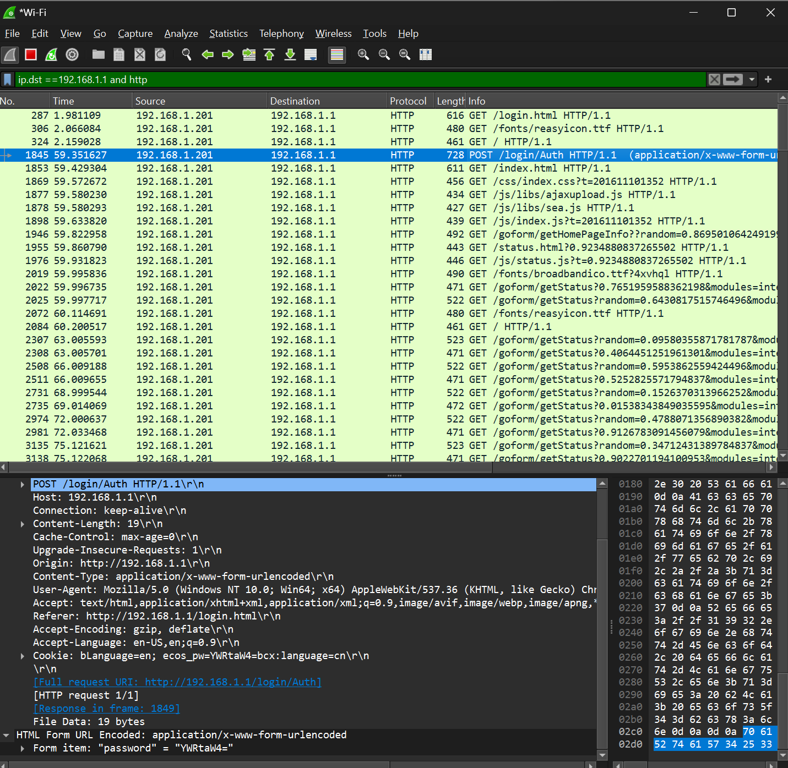

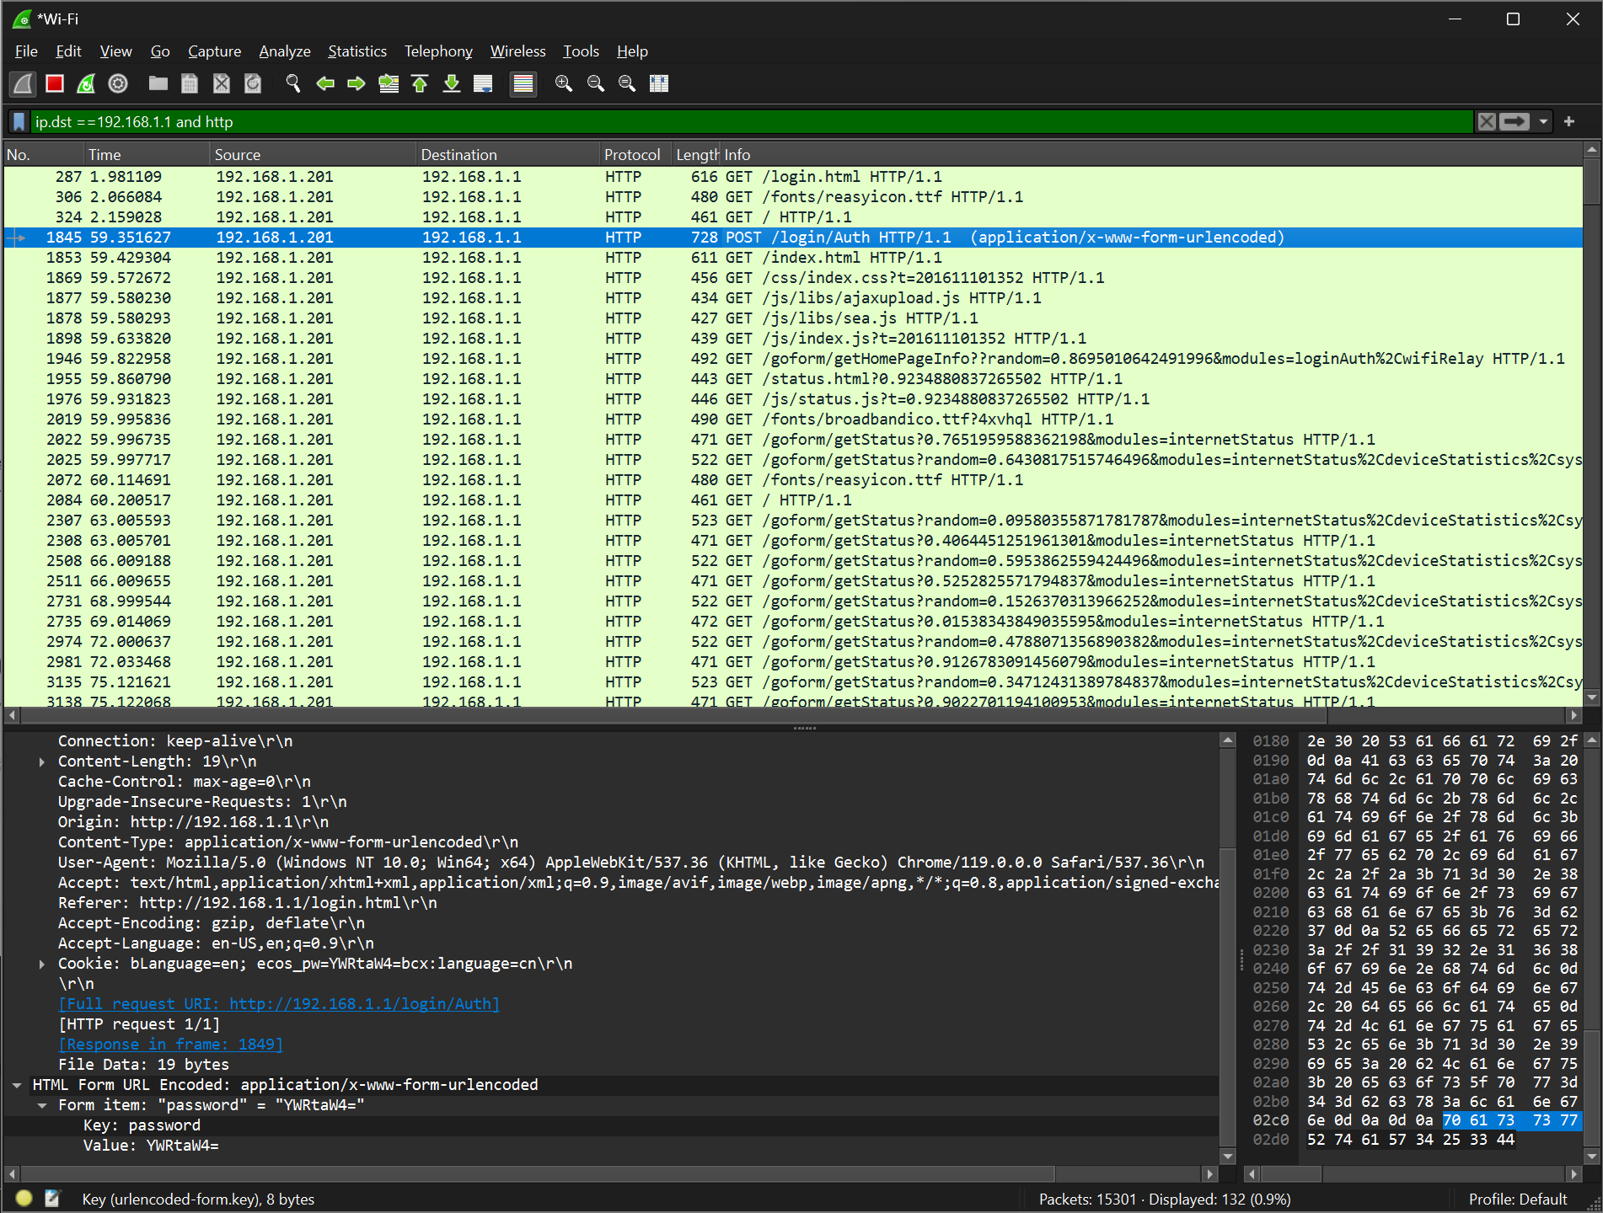

**Information Gathering from the following website:**

[**http://testphp.vulnweb.com/login.php**](http://testphp.vulnweb.com/login.php)

**Gathered the username and password using the HyperTEXT Transfer Protocol**

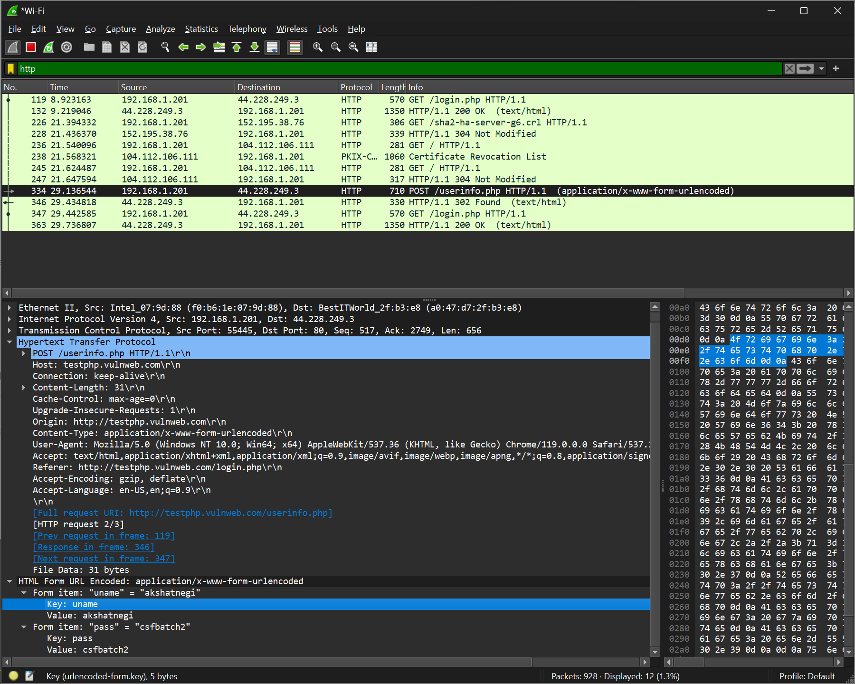

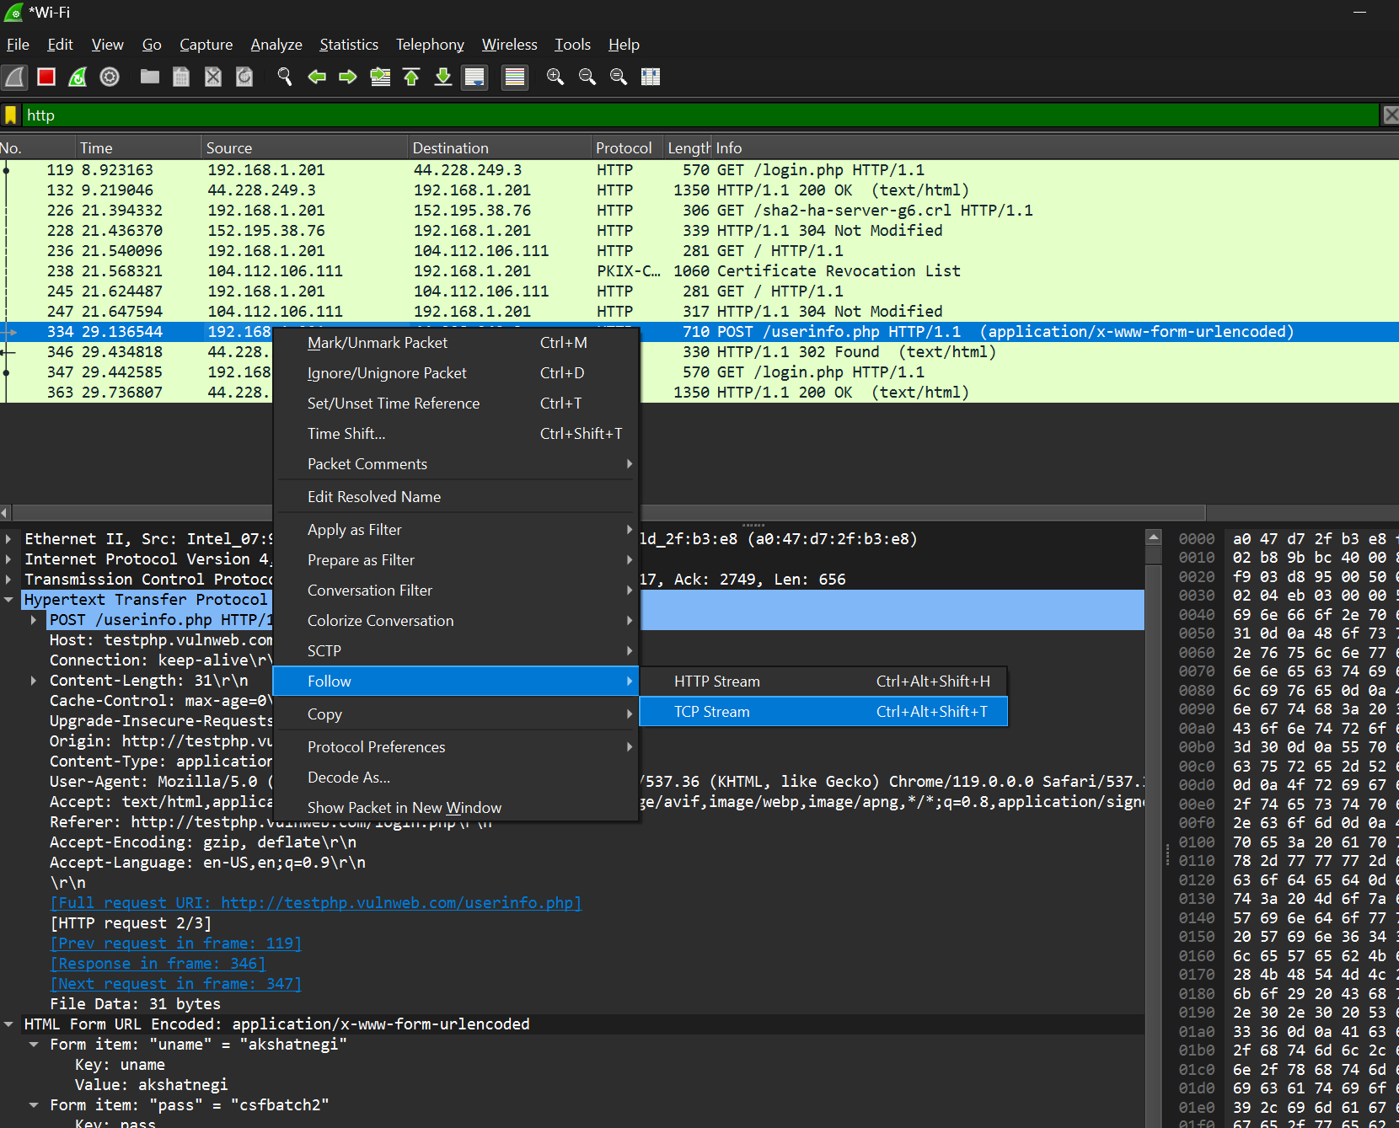

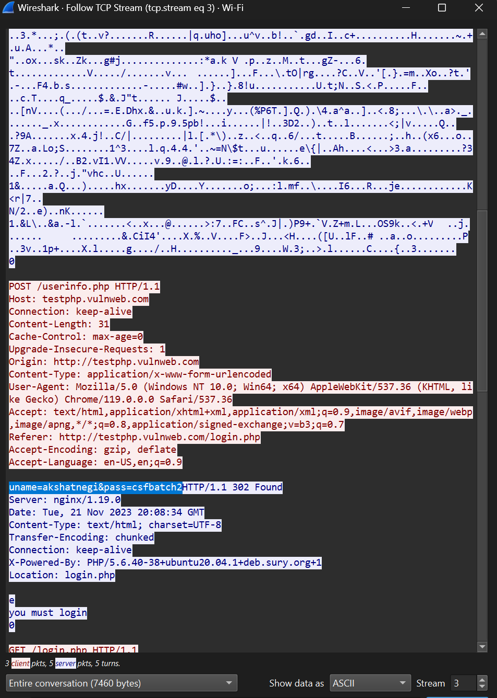

**UDP Filter**

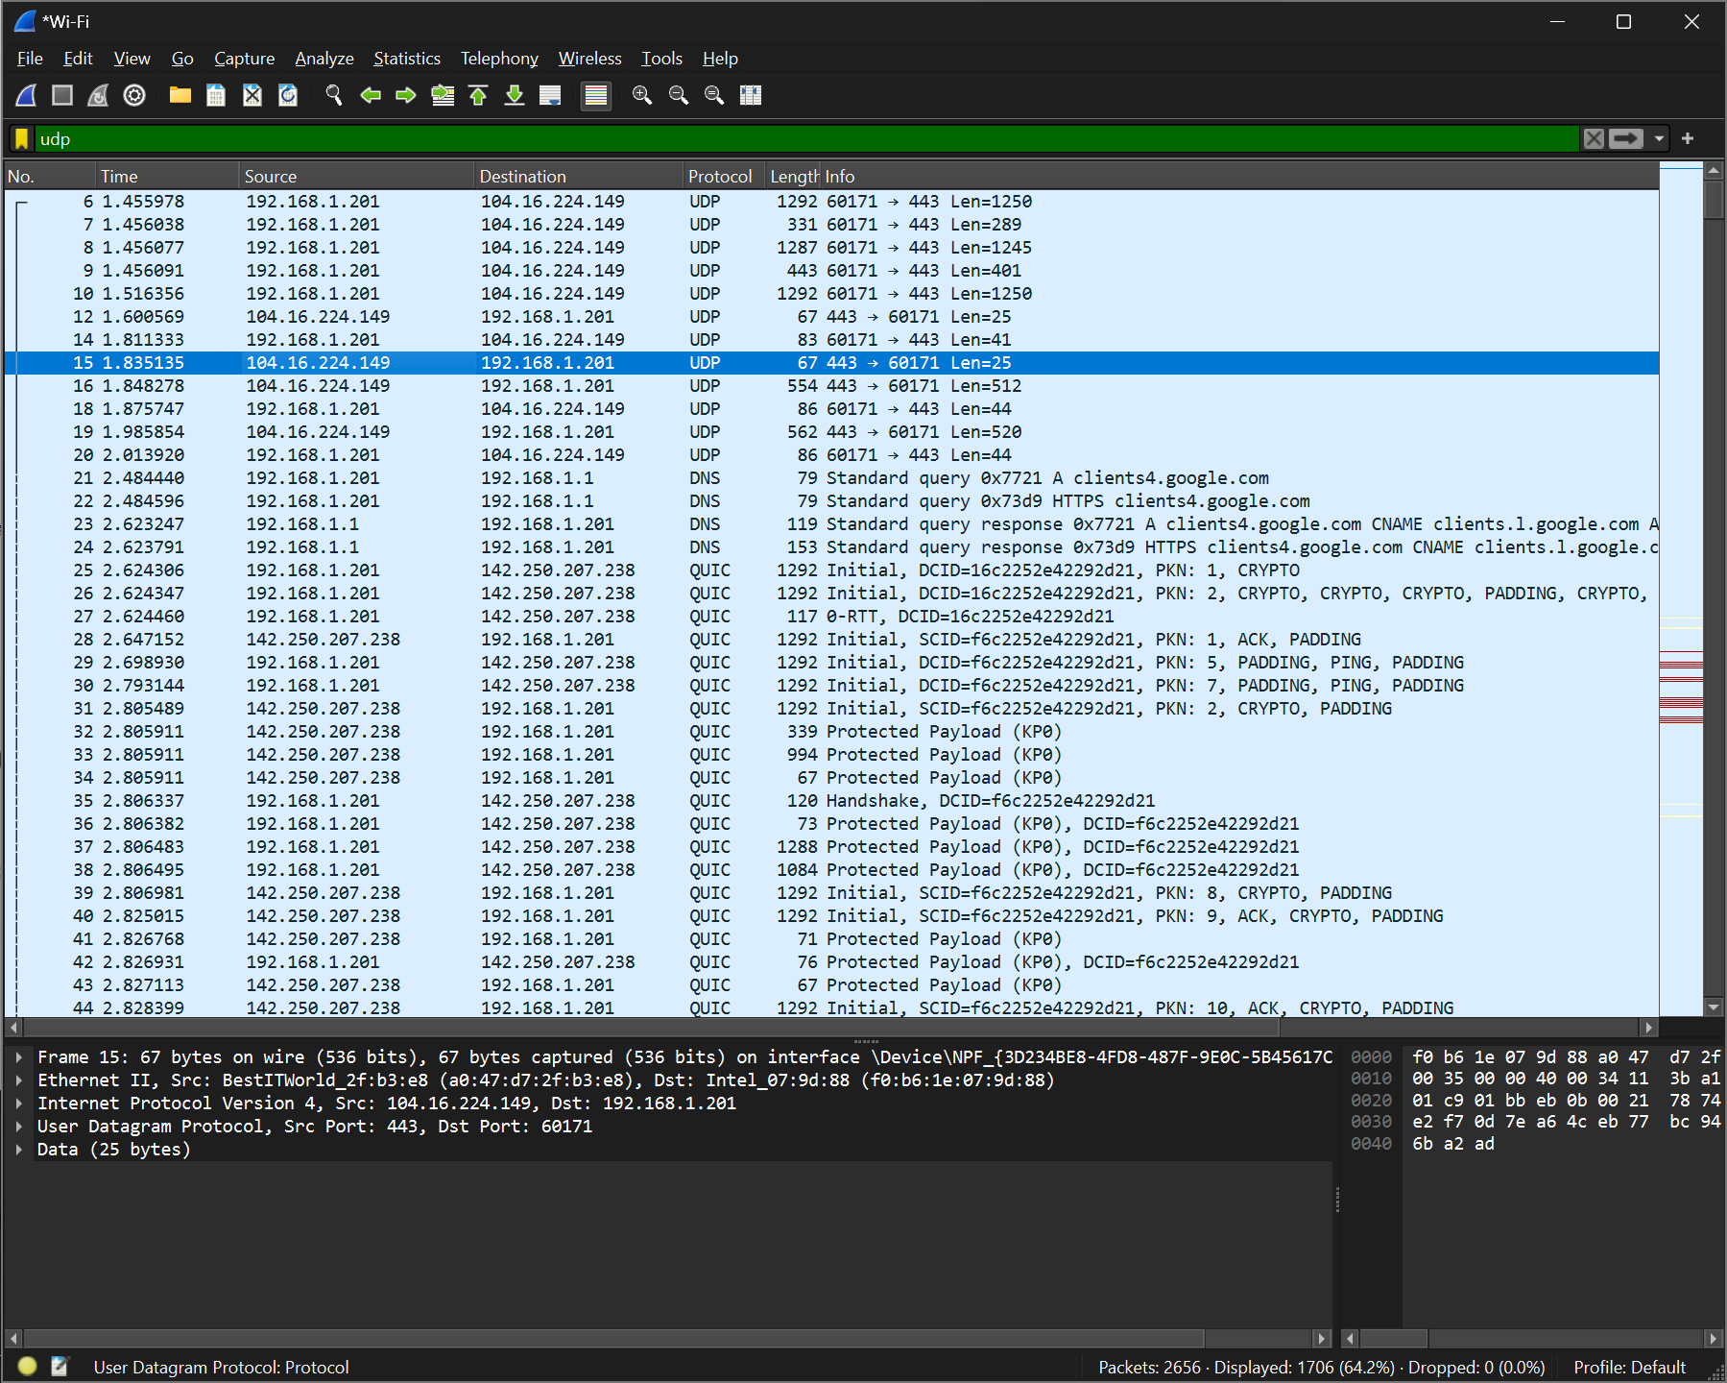

**TCP Filter**

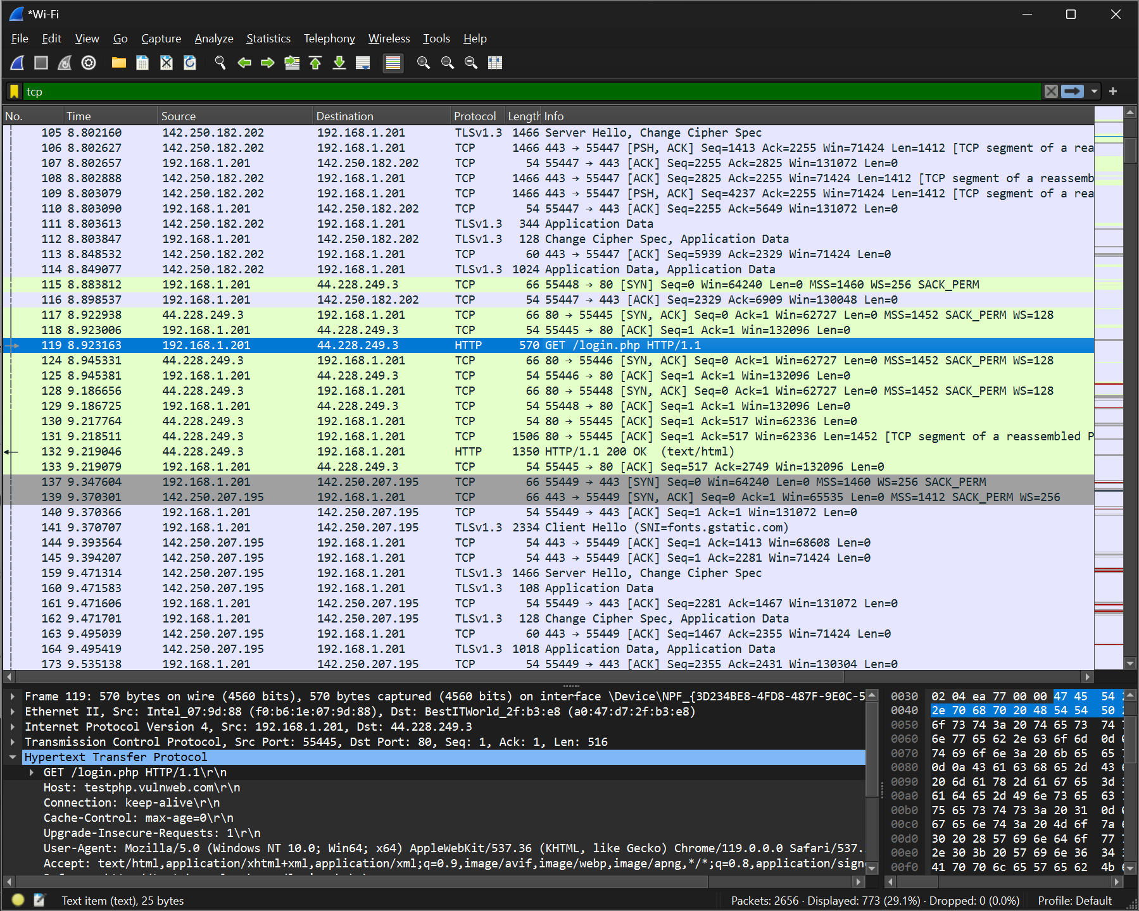

**HTTP Filtered**

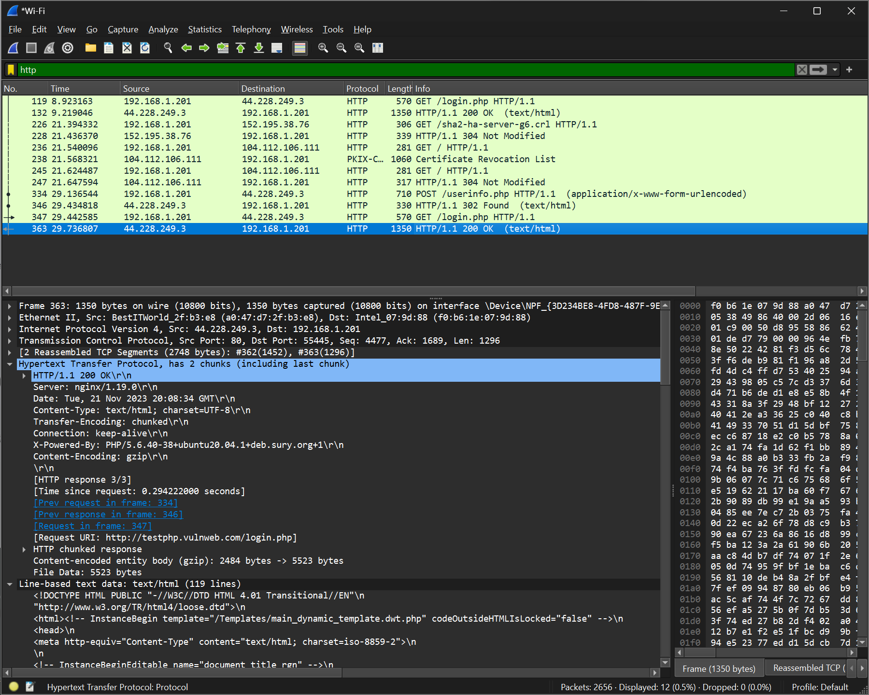

**To check which websites are surfed on a network (only http websites)**

